

CAIRO UNIVERSITY

FACULITY OF COMPUTER SCIENCE

AND ARTIFICIAL INTELLEGENCE

CREDIT HOURS SYSTEM

NETWORKS TECHNOLOGY

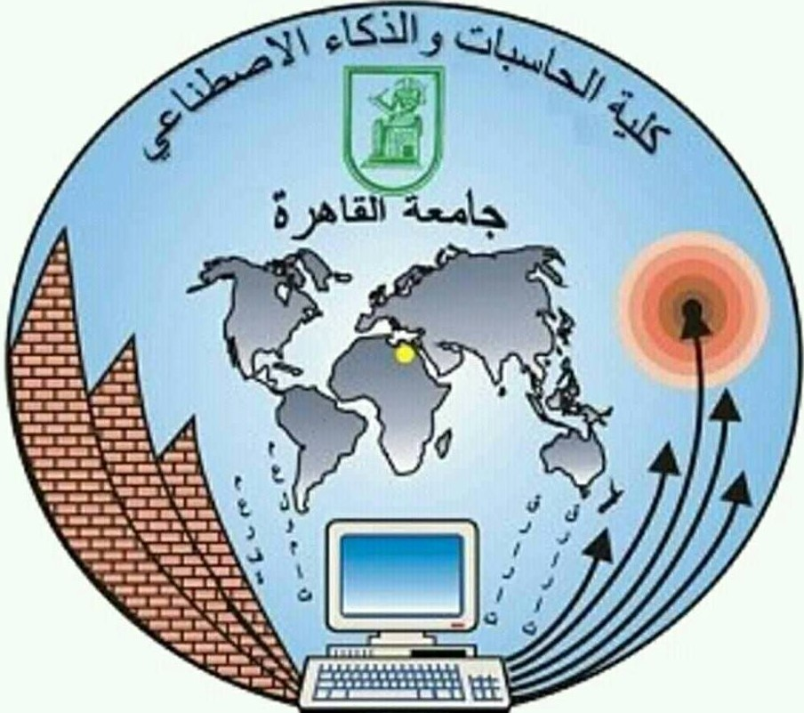

**Design and Implementation of Grab-and-Go system in the Egyptian Supermarkets**



UNDER SUPERVISION OF

**Prof. Dr. Reda Abd El-Wahab**

Implemented by

|  |  |
| --- | --- |
| Sarah Hossam Hamed | 20166014 |
| Abd El-Rahman Mohamed Hamed | 20165002 |
| Abd El-Rahman El-Haj Saieed | 20166018 |
| Menna Gamal Gabr | 20166039 |
| Hagar Sami Abo El-Fath | 20166044 |

**2020**

**TABLE OF CONTENTS**

|  |  |
| --- | --- |
|  | **Page no.** |
| **ABSTRACT** ………………………………………………………………….. | **3** |
| **CHAPTER I:** Introduction ………………………………………………... | **5** |
| * 1. Overview ……………………………………………………......... | **5** |
| * 1. Motivation ………………………………………………………… | **6** |
| * 1. Objective …………………………………………………………... | **7** |
| * 1. Report layout ……………………………………………………… | **8** |
| **CHAPTER II:** Survey Study ……………………………………………..... | **11** |
| **CHAPTER III:** Architecture ………………………………………………. | **13** |
| **CHAPTER IV:** Plan of Work ……………………………………………… | **18** |
| **CHAPTER V:** Current status of the project ……………………………. | **20** |
| **CONCLUSION** ………………………………………………………………… | **26** |
| **REFRENCES** …………………………………………………………………... | **27** |

**ABSTRACT**

Everyone suffers from overcrowded checkouts in addition to slow moving queues searching for loose change of currency while doing grocery shopping. Automated shopping experience based on using alternate convenient methods of cashier free shopping to avoid these stressful events and to improve and speed up the checkout processes.

For this purpose, a new system needs to develop where using combination of the computer vision, machine learning, deep learning algorithms and sensor fusion. The camera that implemented along with the facial recognition algorithm that is done using **open CV** library in python for tracking and monitoring who enter and leave the supermarket. It also uses a framework to send readings from camera and **RFID** sensors using a database as a backend to determine which shopper picks up which item. Therefore, the aim of the current project “Grab and Go” is to develop and implement a system to help customers to check out the selected items in real time. As well as, all data and information for the costumer will processed once he exited the store. This processed data will help the retailer to analyze the user needs and interest of specific items. On the other hand, the user will save his time spent in paying. Our system will full automate the process by detecting the selected picked item from the shelf and put in the user virtual cart. Finally, these items will be collected and he paid for them using an electronic wallet or bank cards that the customer had already added while registration.

**Keywords:** IOT(Internet of things) , Nodemcu , Virtual cart, Android, open cv, RFID, mySQL .

**CHAPTER I**

1. **INTRODUCTION**

Today, Egyptians prefer to get their groceries from supermarkets and hypermarkets scattered in all parts of Egypt. The traditional operations such as checkout, payment, inventory reports have been carried out with the human dependence. This process involves many of different technological traits. Recently, our life moving toward the fully automation and ease process to save our time.

* 1. **OVERVIEW**

Recently, many studies focus on solving problems that faces customers when they do shopping. Among these recent studies, come our study solution which concluded in design and implementation of new system named “Grab and Go system”. This system will help customers to grab the product that they needs and just walkout from the store that eliminates the waiting time in queue for payments and save their valuable time because once the customer leaves the supermarket the items price will be paid from his payment card through the application. On the other hand, this new system will help also retailers to analyze the users need and interest. Also, system allow retailers to be notified when product is picked u3p or when a theft is detected, and when products are misplaced, provides access to the store or shelf information remotely, enables visibility of stock position and minimizes out-of-stock situations and lost sales opportunities. As well as, grab and go will helps manufacturers in evaluate their products and enables manufacturers to reward shopper loyalty. Therefore, Grab and Go system will automate the whole process by detecting the items picked out of the shelf by users. It makes the system attractive to both customers and shop owners perspective.

* 1. **Motivation**

What motivates us to implement this project is that nowadays many payment methods are used in different supermarkets and groceries. Examples of these methods are:

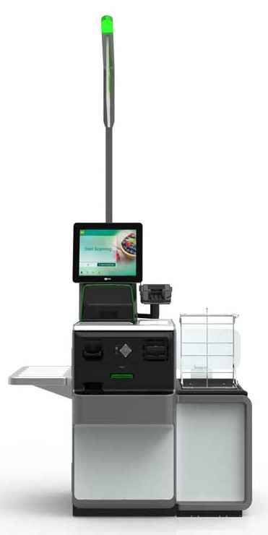

1. **The traditional Fixed self-scan machines**: This mode of payment where consumer brings their selected items to a fixed place in the store and proceeds to scan them either using the barcodes present on the items or by choosing the item type from a list of possible options provided by the machine displayed on an interactive screen. Cash or payment card is provided to pay for such shopping’s.

**Fig.1 [self-scan machines]**

1. **Scan and Go Systems**: In this system, customer is provided with a ‘scan stick’ by the retailer which scans the barcodes of items they wish to purchase. At the end of the shopping journey, the user is then required to go to a fixed point and dock their scan stick in a terminal, which then processes the transaction and takes payment from the consumer by his payment card.

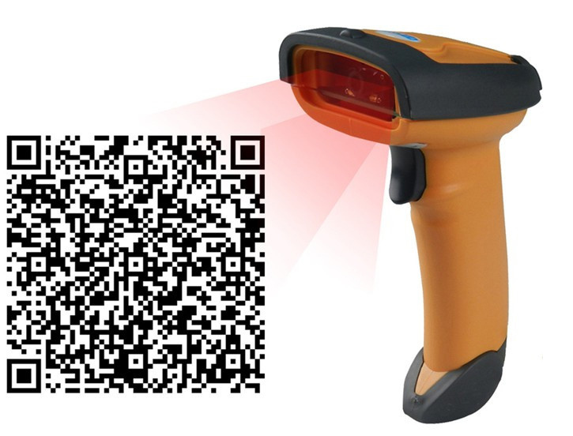

**Fig.2 [scan stick]**

1. 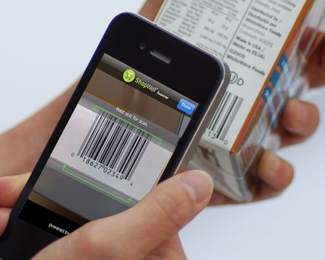**Mobile Scan and Go Systems**: This is the main variant in use now, and one that has only recently begun to be offered by retailers, is similar to the Scan and Go system described above except that instead of using a ‘scan stick’ provided by the retailer, the consumer uses their own mobile device, utilizing the App provided by the retailer and the camera functionality built into the mobile, to scan and record products they wish to purchase. This also provides the option for the consumer to pay for their items anywhere in the store via their mobiles.  **Fig.3 [scan stick]**.

**\* But there are many disadvantages of the previous methods:**

1. Consuming time in checkout and payment process.

2. It needs many of employers to serve all the user demands.

3. The consumer expectations not achieved by the inefficiency in the checkout process.

4. It has personalized and retailer’s visions shortages over the user demand.

According to these disadvantages of the above payment processes, the project target is to find solution to automate the shopping experience which will improve and develop the way for retailers and consumer to be more comfortable.

**Grab and go system have many advantages as the following:**

1. It will remove the time wasted in waiting in cashier rows.

2. No need for human power and checkout counters.

3. Easily handling of the consumer payment process.

4. Retailers can determine the consumer’s interest.

5. Costs, product price, and safety costs would go down.

**But also have many disadvantages as the following:**

1. maintenance of sensors will increase the OPEX (Operating expenses ) of the shop
2. The cost of the sensors and cameras which will increase CAPEX (Capital expenditures) of the shop.
3. Attacks on the system is expected.
   1. **Objectives**

The main target of the project study is reached to the optimal solution for the problems of the traditional systems used in supermarkets and groceries. Grab and Go uses what we call,

**“Just Walk Out Technology”.** This technology is responsible for keeping track of items taken from, and in some cases, returned to, the store’s shelves. It also keeps track of the individual’s virtual cart.

For this to be possible, **Grab and GO** uses technology similar to that of self-driving cars. The system relies heavily on **sensor fusion, computer vision, and deep learning algorithms** .cameras is the central to the operational strategy. Cameras will track not only the products and their placement, but also the individuals who do the shopping.

The hardware used is NodeMCU (esp8266), RFID reader, RFID tag and cameras, while the software integration including MYSQL database, Android and open CV in python for facial recognition. Both of hardware and software are need to be efficient to handle the processed data in real-time. Any actions happen in the used systems will be updated on the database. The designed system will use the communications between the different types of nodes which including, the embedded sensors, user application, manager applications, database and cameras to process all data and information. Moreover, each portion in the grocery that use our system can be managed automatically using Server.

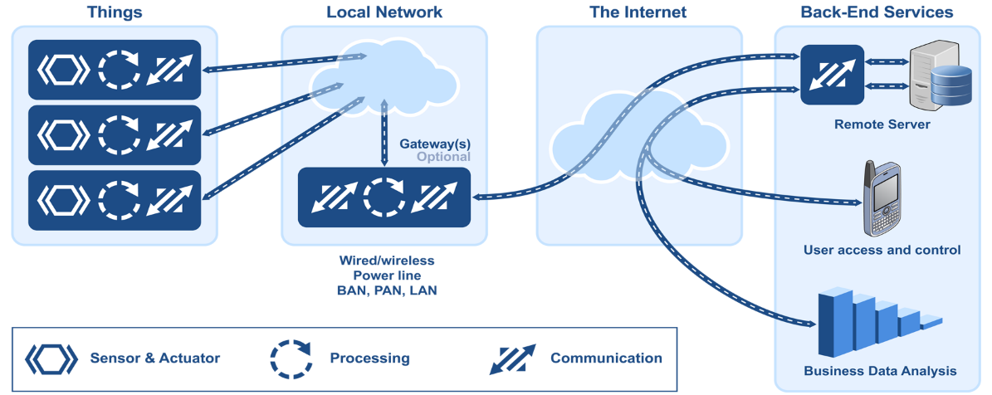

Fig. 4 [IOT from an embedded system point of view]

First, the user will register with his photo in Grab and Go android application, the when the customer enters the shop first he will stand by the biometric identification terminal [Fig.5]

That has cameras to detect if the customer is found in the shop’s database or not. When the user is validated he will enter the shop and starts his shopping experience. At the shop’s shelves camera is fixed on each shelf and a RFID reader fixed at the end of the shelf that continuously scans the RFID Tags (that is sticked on each product that have the product’s ID) to detect the picking up of the products . So, when the customer grabs a product the RFID reader will detect the product’s ID [Fig.6] and the camera will identify the identity of the customer who grabs the product [Fig.7] and sends these data to the main server and the server communicate with the database to detect the customer’s account and adds this product to his virtual cart. When the customer finishes his shopping process he will exit the shop from the exit gates that has w fixed camera that detects the departure of the customer and communicate with the server to send the customer his shopping receipt with the payment that is taken from his credit card.

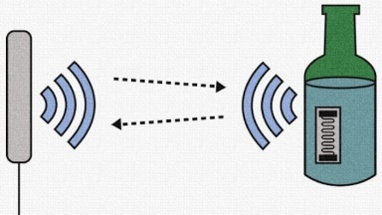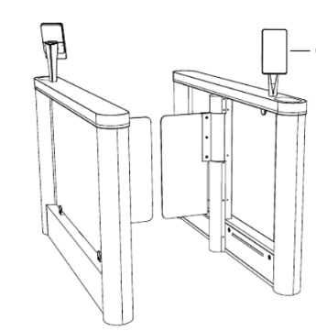

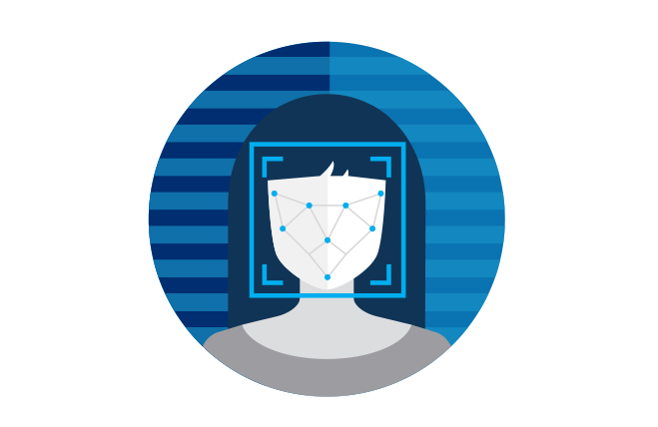Fig.5 [biometric identification terminal] Fig.6 [RFID reader reads the RFID Tag]

Fig.7 [Face Detection]

* 1. **Report layout**

The project study contains five chapters, the first one is concerned with the introduction which included four sections as overview that clarify the importance of the project and how our technology help people in shopping process,

Motivation which focus on reasons that motivate us to make this solution,

Objectives which display the project idea and sequence from the scientific side and report layout that explain the document.

The second chapter is the study survey which display the similar technologies and their disadvantages and how our project solve it all. The third chapter was the architecture that explain clearly how the sequence of processes done actually. The fourth chapter was the plan of work that display our completed tasks and next tasks that we will finish it in next semester.

The fifth chapter was current status of the project which contains the actual implementation of the system. Then the study work finished by the conclusion.

**CHAPTER II**

**SURVEY STUDY:**

The digital technology has play an important role in the human life, it simplifies the daily activities such as the shopping process. So many of shopping companies are competing to facilitate the purchase process to the customers. Among these companies, Alibaba, JD.com and Amazon Go.

We will discuss the different systems used by these shopping companies as the following:

1. **Hema application:** Chinese retail giant Alibaba has been growing its chain of cashless Hema grocery stores. Once users have downloaded the Hema app (which is integrated with Alipay) they can start the shopping process by the following sequences, scan any item in the store to see its origins, order the selected food from the store restaurant and have it delivered by robots at select locations, receive personalized items and recipe suggestions, order products within 30-minute delivery at home or in store and finally, checkout and pay.
2. **JD.com**, China’s second largest e-commerce platform, [opened](https://www.caixinglobal.com/2018-01-03/jdcom-unmanned-grocery-store-goes-live-101192805.html)its first human-free convenience store. The visitors scan their phones to enter the store and again to pay and exit. The stores use shelf sensors, cameras and facial recognition tools, and RFID tags to track people and products.
3. **Amazon Go**: Customers scan their Amazon Go app to enter the store and get charged automatically as they pick up items and exit. Amazon uses shelf sensors and cameras to track people and the products they interact with. The cameras use machine vision, but not facial recognition.

The previous shopping systems suffers many of problems that solved by grab and go system:

* In Alibaba system, the customer will scan the product he wants and then will be delivered at home or any place in 30 minute so it will take more time to get the products. But with our technology will speed up the process of getting the product and paying.
* The second issue in JD.com and Amazon Go when they use the bar code to let customers enter the grocery and to identify them by scan the bar code by their mobiles but in case of theft any mobile phone of one of the customers it will be possible to enter the grocery as owner. But we solve it in our system by let customers enter the grocery and identify them by comparing their taken pictures by the camera put in the grocery gate and their pictures stored in the database.

**CHAPTER III**

**ARCHITECTURE :**

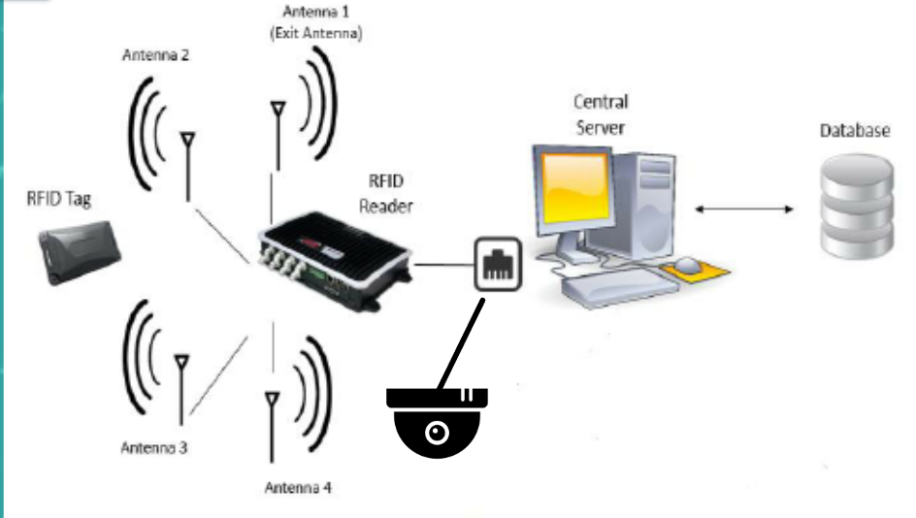

**Fig. 8** Architectural overview of proposed system

The system consists of different modules communicate with each her’s. All the actions are stored in the central database. The communication between the modules are shown in Fig. 8 which is the proposed overall structure of the system.

1. **Cameras:**

These cameras are the most important entities of this system because they identify customers and it is backed up with facial recognition algorithm.

Whenever someone stop front of any shelf and when the customer picks up any product at that moment the camera will detect this customer and send his/her photo to the server to process on it. At the server there is a python code with opencv library included in it which used in face detection and the python program is responsible for comparing this photo with other photos that are stored on database and finds the best matched photo for the taken photo

As well as the customer will enter or exit the grocery by taking a snapshot of the customer and compare it with the photo that stored on database.

1. **Database:**

We will be using database to store the data. It is responsible for all the customer data (id, photo), inventory management, and user virtual carts. Database takes information from RFID reader which include sensors, those information includes the ids of missed tags to determine which product has token. Cameras also sends its photos to database to be compared with stored data to determine the person and his /her id.

1. **OpenCV** :

OpenCV is a library of Python bindings designed to solve computer vision problems. OpenCV is responsible for detecting faces and comparing its features with features stored on database. We prefer to use python code because most of it’s libraries is for free rather than c# for example.

1. **Server**  :

Uses a python code with opencv library included for face recognition and

It return the best matched photo by interacting with database and send to the database to add the product to this user or allows his entrance or detect his departure.

1. **RFID reader and RFID tags :**

The RFID reader is placed at the end of the shelf, so when a product is grabed by the user it will detect the product’s ID and send it to the database in order to add the product in the customer’s virtual cart. Each RFID Tag has the ID of a product which is unique to identify the product’s name and price.

The type of our rfid reader is RC522, its band frequency is 13.56 mhz. in our project we use a passive reader with ranges from 3 cm to 6 cm.

1. **nodeMCU :**

In our project we use nodemcu microcontroller ESP8266-12E WIFI to connect rfid reader with our server through wifi

**7. User Application;**

The customer will register on the store’s application. The customer’s data will be store in the database of the store’s system with his photo and a unique ID.

Once registered, the customer is allowed to enter the store through only identifying the user face by the face detection algorithm installed in the biometric terminal at the store gates. Actions will be shown on application like showing the bill after leaving the shop, report a problem, showing user’s history and showing if the customer is in or out the store.

* User Application Layout :

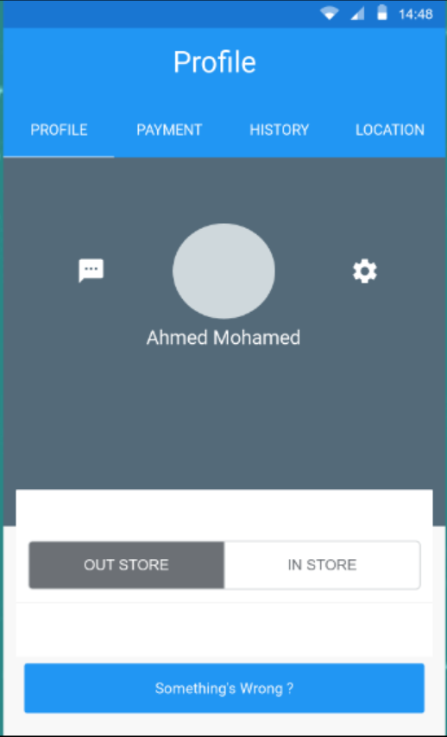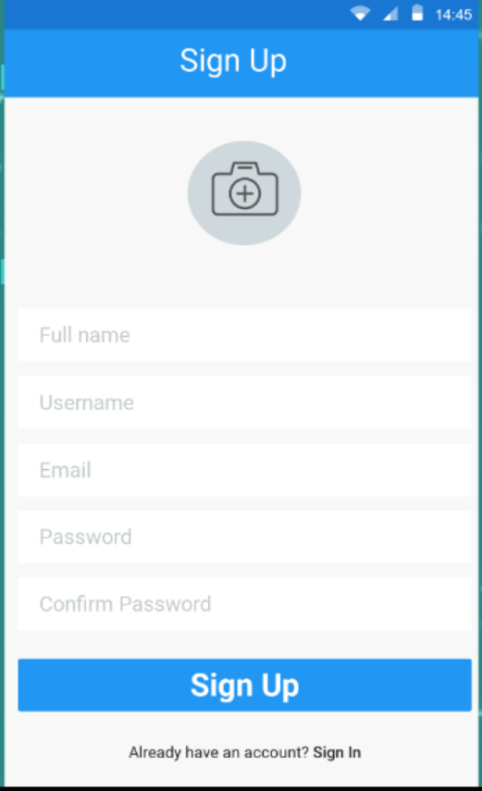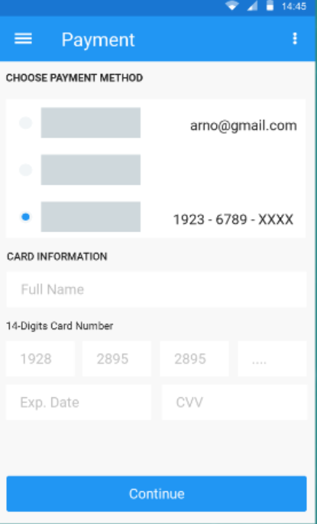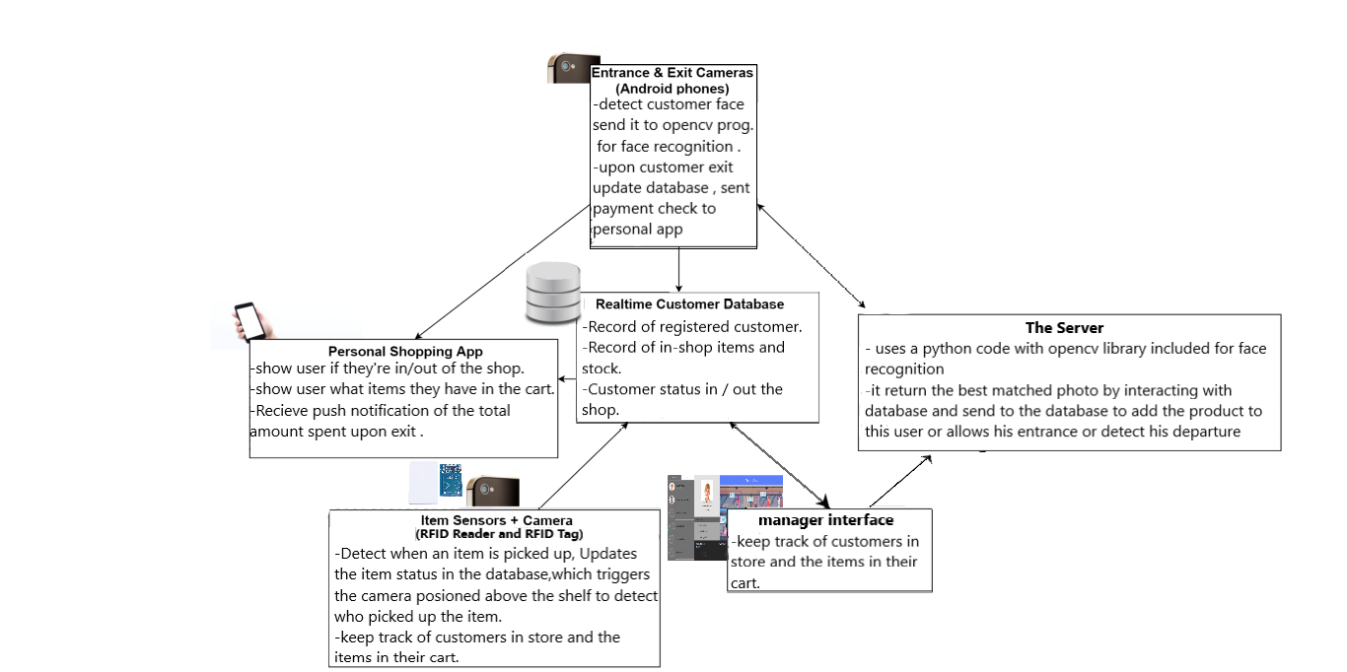

**Fig. 9** Data flow diagram

**CHAPTER IV**

**PLAN OF WORK:**

1. **Completed Tasks :**

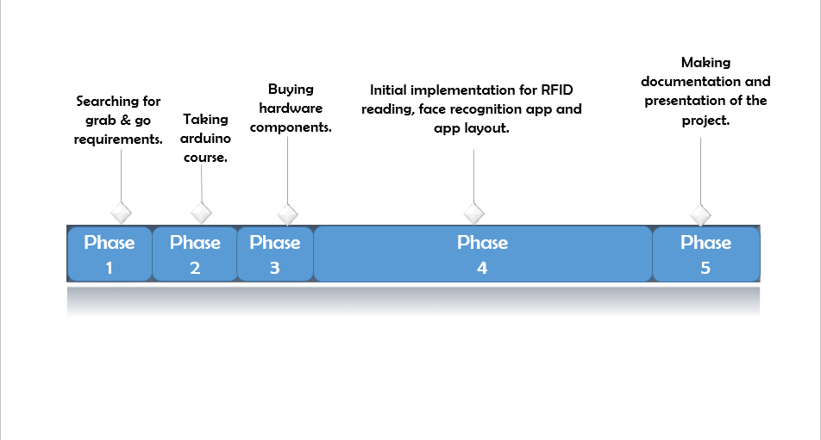

1. **Plan of work :**

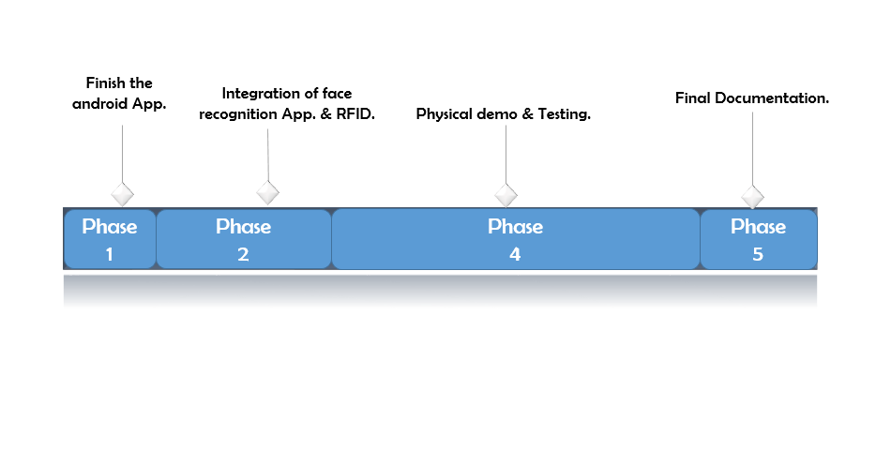

**CHAPTER V**

**Current Status of the Project:**

1. **Face Recognition and Detection :**

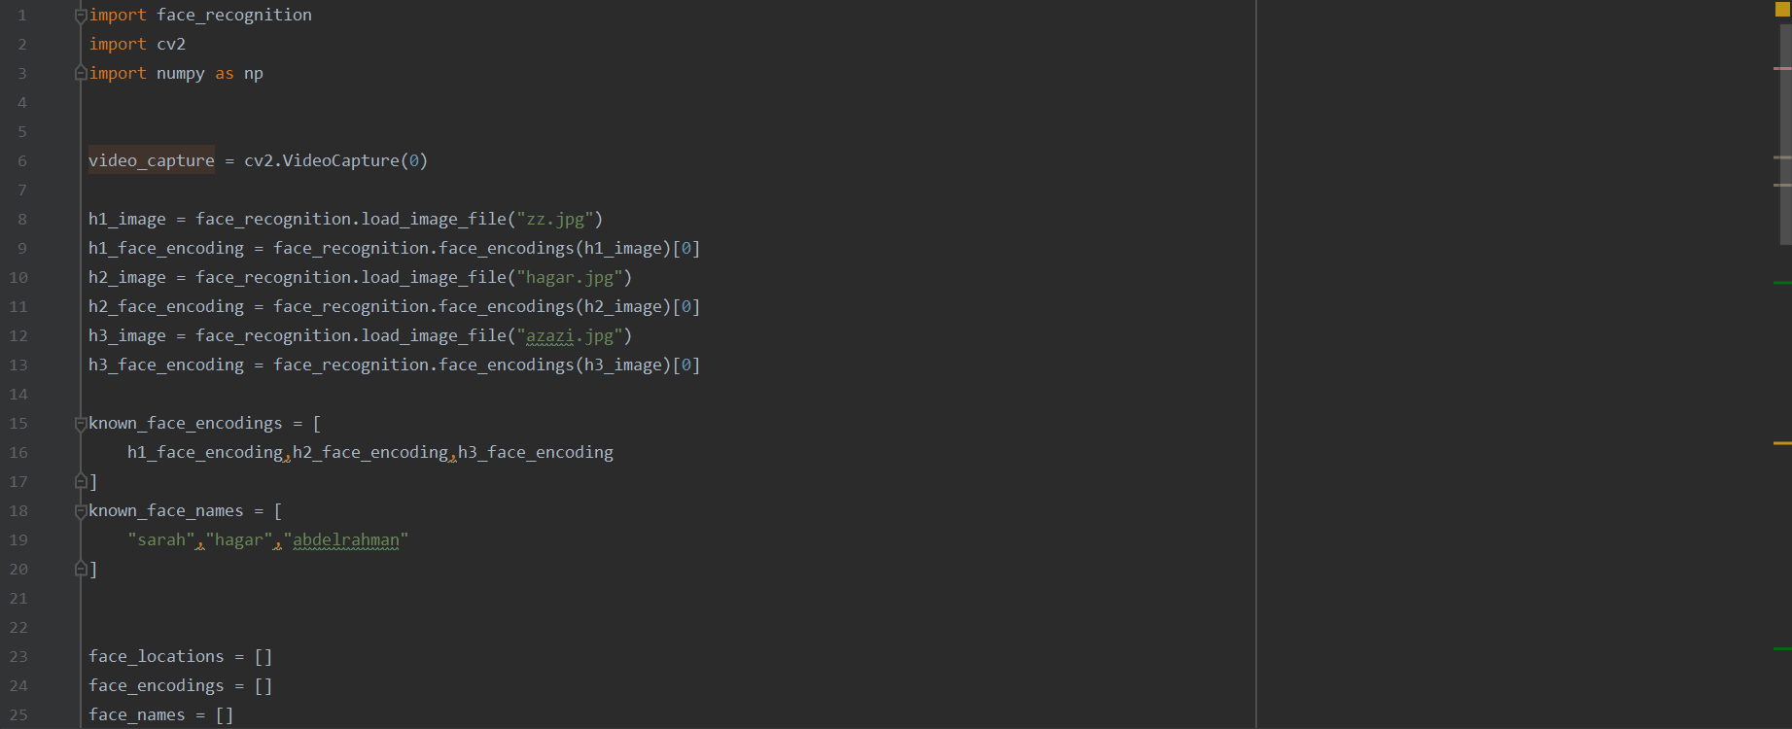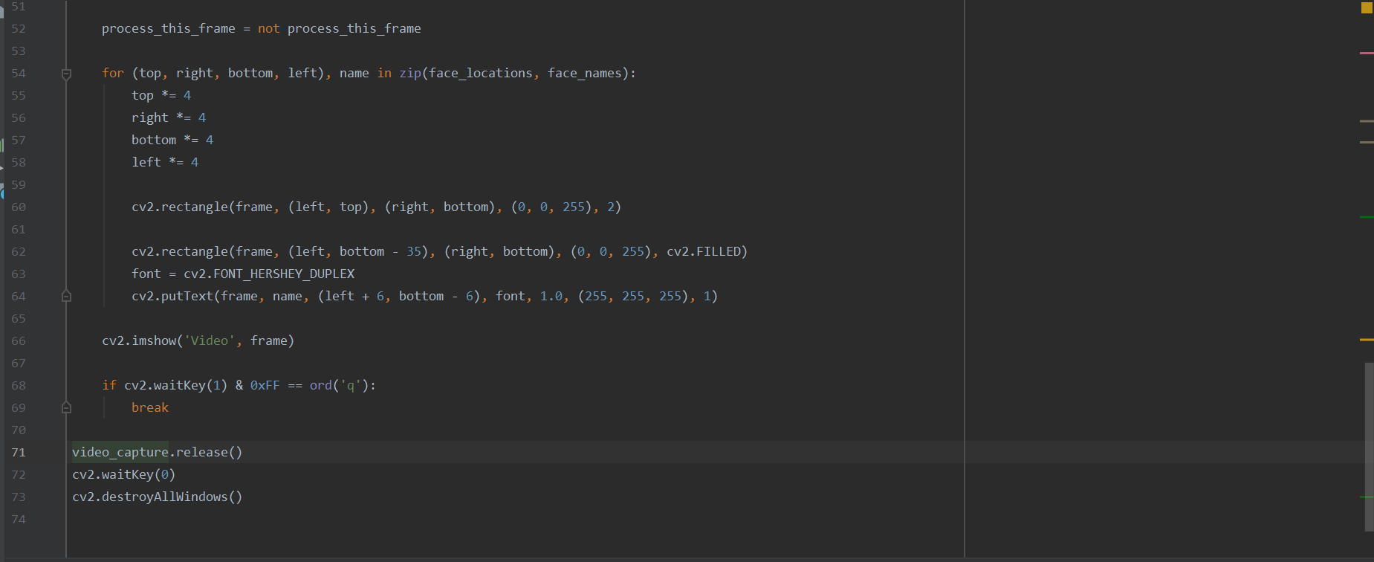**1) Python code:**

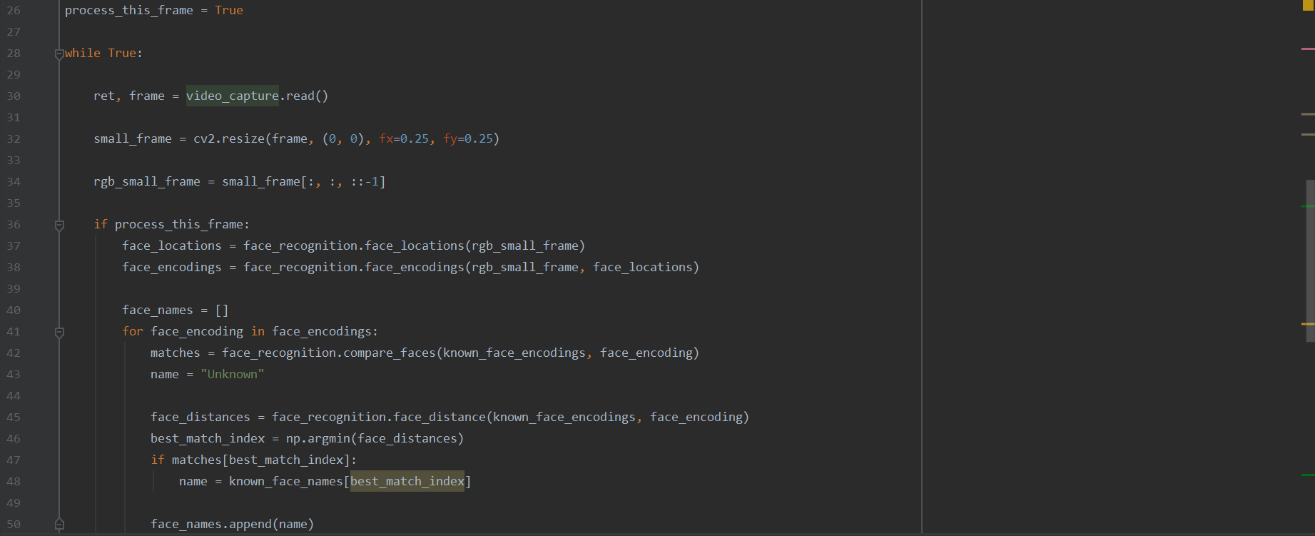

1. **Demo :**
2. **RFID Reader Connection with NODEMCU :**

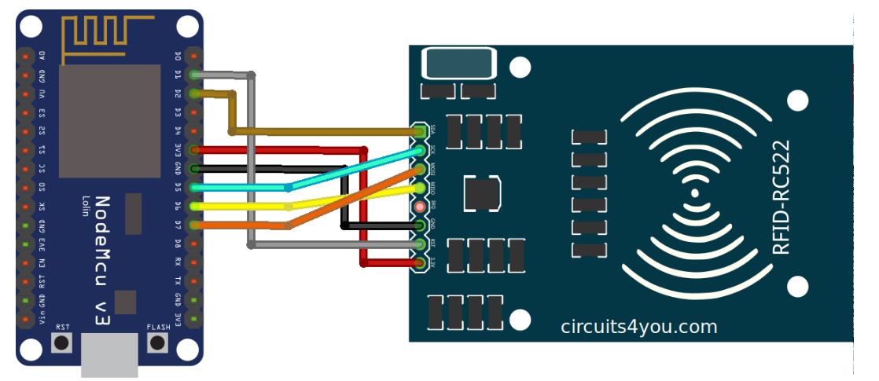

**2) RFID Reader reading RFID Tag Code:**

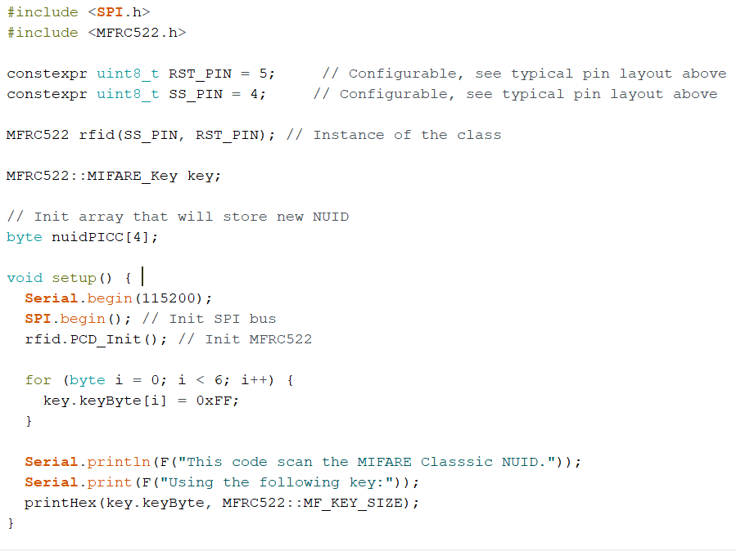

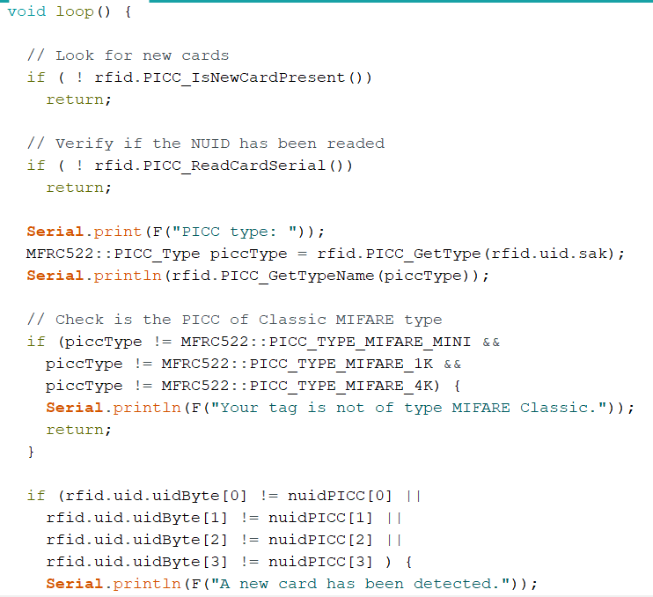

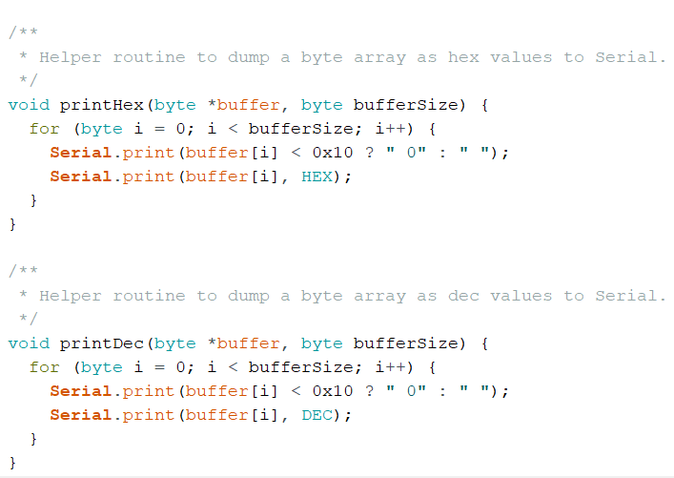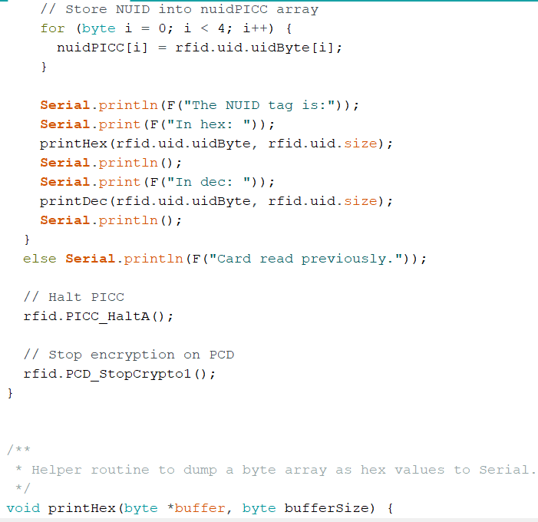

**Conclusion:**

To sum up, in this report we were talking about he just walkout technology and how we used this technology with the hardware components to build a cashierless supermarket and our current status and our plan of work .

**References**

1. S. Pradhan, E. Chai, K. Sundaresan, S. Rangarajan, L. Qiu, Konark: a RFID based system for enhancing in-store shopping experience, in Proceedings of the 4th International on Workshop on Physical Analytics (ACM, USA, 2017), pp. 19–24
2. U. Gangwal, S. Roy, J. Bapat, Smart shopping cart for automated billing purpose using wireless sensor networks, in SENSORCOMM 2013: The Seventh International Conference on Sensor Technologies and Applications, vol. 7, pp. 168–172 (2013)
3. O. Boyinbode, O. Akinyede, A RFID baed inventory control system for Nigerian Supermarket Int. J. Comput. Appl. 116(7) (2015)

4. Mou, S.; Robb, D.J.; De Horatious, N. Retail store operations: Literature review and research directions. Eur. J. Oper. Res. 2018, 265, 399–422.

1. Online and In-store Shopping: Competition or Complements? http://genyu.net/2014/12/09/online-and-in-store-shopping-competition-or-complements/, 2017.
2. Study Finds Shoppers Prefer Brick-And-Mortar Stores to Amazon and EBay. <https://www.forbes.com/sites/barbarathau/2014/07/25/report-amazonsgot-> nothing-on-brick-and-mortar-stores/#7557597262d0, 2017.
3. The Retailer’s Dilemma: a Brick-and-Mortar or Brand Problem. <https://go>. forrester.com/ep06-the-retailers-dilemma/, 2017.
4. O. Boyinbode, O. Akinyede. A RFID based inventory control system for Nigerian supermarkets. International Journal of Computer Applications. 2015;116(7):7–12. DOI: 10.5120/20346‐2531.